13.1.2 Editors - Video Sequence Editor - Header - View Menu
Type of Sequencer View 2
View Menu in Preview window 2
Sidebar 2
Toolbar 2
Fit Preview in Window 2
Zoom Border 2
Fractional Zoom 2
Proxy 3
Setup 3
Rebuild 3
Scene Render Size 3
Sequence render Image 3
Sequence render Animation 3
Toggle Sequencer/Preview 3
Area 3
Horizontal Split 3
Vertical Split 3
Duplicate Area into New Window 4
Toggle Maximize Area 4
Toggle Full screen Area 4
View Menu in Sequencer window 4
Sidebar 4
Toolbar 4
Adjust Last Operation 5
Frame all 5
Frame selected 5
Zoom Border 5
Refresh all 5
Sequence render Image 5
Sequence render Animation 5
Toggle Sequencer/Preview 5
Area 5
Horizontal Split 5
Vertical Split 5
Duplicate Area into New Window 6
Toggle Maximize Area 6
Toggle Full screen Area 6

Type of Sequencer View

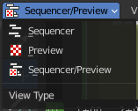
The Video Sequence Editor is two editors in one. The Preview sequencer view is a preview window. Here plays the video. The Sequencer sequencer view is the view that contains the the video and audio strips.

View Menu in Preview window

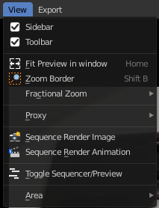
The View menu contains all View related tools.

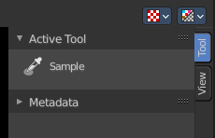
Sidebar
Shows or hides the sidebar at the right in the viewport.

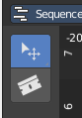
Toolbar
Shows or hides the toolbar at the left.

Fit Preview in Window
Zooms in or out until the video displays fitting in the viewport.

Zoom Border
Zooms to the selection.

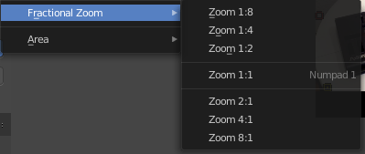
Fractional Zoom
A set of predefined zoom factors.

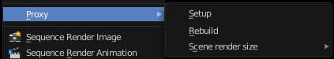
Proxy
Proxy works just with movie or image strips. What it does is to create a smaller set of preview images. This speeds up the calculation while you are at editing the video. The final result uses the final images again then.

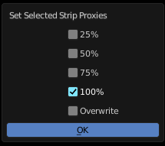
Setup
Calls a panel where you can choose the resolution of the proxy images. Clicking Ok starts the creation process.

Rebuild
Recreates the proxy images

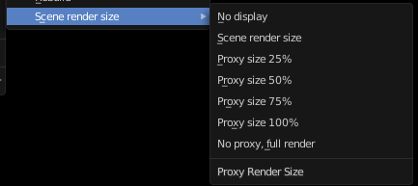
Scene Render Size
What render size the display should choose.

Sequence render Image
Renders an image of the current frame.

Sequence render Animation
Renders the animation in the preview range.

Toggle Sequencer/Preview
Toggles the type of sequencer view between Sequencer or Preview.


Area
This menu contains general view functionality. And exists in most other editor types too.

Horizontal Split
Splits the current view horizontally into two independant editor windows.

Vertical Split
Splits the current view vertically into two independant editor windows.


Duplicate Area into New Window
Duplicate Area into New Window makes the selected editor window floating. You can then drag it around at the monitor. It is not connected with the rest of the UI anymore.
A separated window cannot be merged into the main window again. You have to close it when not longer needed.

Toggle Maximize Area
Displays the editor maximized with menus.
To return from the maximized view press hotkey ctrl + spacebar. Or reuse the menu item in the area menu.

Toggle Full screen Area
Displays the editor maximized without menus.
To return from the full screen view press hotkey ctrl + alt + spacebar.

View Menu in Sequencer window

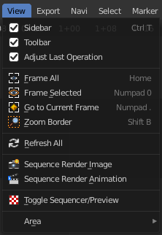
The View menu contains all View related tools.

Sidebar
Shows or hides the sidebar at the right in the viewport.

Toolbar
Shows or hides the toolbar at the left.

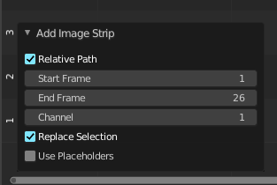
Adjust Last Operation
Displays the Adjust last operation panel down left.

Frame all
Zooms in or out to display all elements fitting into the view.

Frame selected
Zooms in or out to display the currently selected element fitting into the view.

Zoom Border
Zooms to the selection.

Refresh all
Refreshes the sequence editor.

Sequence render Image
Renders an image of the current frame.

Sequence render Animation
Renders the animation in the preview range.

Toggle Sequencer/Preview
Toggles the type of sequencer view between Sequencer or Preview.

Area
This menu contains general view functionality. And exists in most other editor types too.

Horizontal Split
Splits the current view horizontally into two independant editor windows.

Vertical Split
Splits the current view vertically into two independant editor windows.

Duplicate Area into New Window
Duplicate Area into New Window makes the selected editor window floating. You can then drag it around at the monitor. It is not connected with the rest of the UI anymore.
A separated window cannot be merged into the main window again. You have to close it when not longer needed.

Toggle Maximize Area
Displays the editor maximized with menus.
To return from the maximized view press hotkey ctrl + spacebar. Or reuse the menu item in the area menu.

Toggle Full screen Area
Displays the editor maximized without menus.
To return from the full screen view press hotkey ctrl + alt + spacebar.

